Assignment (Iris Data)


Solution

- Import pandas.


- Download Iris dataset and read it.
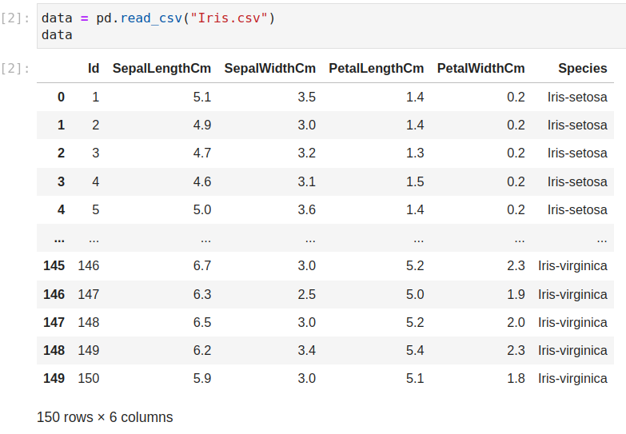
- Find the average Sepal Length of each Species.
